Classroom Management Plan
Allison Meyer
EDU 301

Abstract
This paper highlights some of the things I intend to include into my future classroom. It also goes into depth of the strategies and styles of classroom management I plan on incorporating into my teaching style. I will include some basic rules or rather procedures my classroom will have from the beginning of the year into my plan.

Classroom Management Plan
On the first day of EDU 301, otherwise known as Classroom Management, the professor asked us to complete the following sentence: “Classroom management is….” My answer was along the lines of “Classroom management is a way to teach that is constructive to learning.” I had long since forgotten that I had answered that prompt until the last day of class when the professor brought them to class and had us read what we had answered that first day and then answer the same prompt, but this time, using the information we had gained throughout the semester. The main point behind my answer was not necessarily different, but more specific the second time I answered it. I added in details like “fun”, “safe” and “environment”. Throughout this semester I have learned a large variety of ways to manage my classroom. I have picked up strategies and procedures I can incorporate into my classroom to prevent poor behaviors or encourage positive behaviors from occurring within the classroom.
Classroom management is a set of procedures and instructions that are necessary to create an environment that is fun and safe, an environment that is constructive to learning. As a classroom teacher, I will pull my management strategies from Marzano, as well as Wong and love and logic. Each set of strategies are great, however they become even more powerful if all three are used together in balance of one another. For some students, love and logic is the easiest way for them to understand and correct the situation, whereas other students need a strict set of rules and procedures. As a teacher, I will implement a little bit from each of the three strategies.
I will create an environment that is a safe and fun place to be. My classroom will be geared toward learning. I will provide an environment for students to enter and know they have a voice that will be heard. My classroom will be a classroom that keeps students engaged and excited to learn.
At the beginning of the year, I will start by using Wong’s strategies of using rules and procedures. One cannot start the year off without having a few set procedures and rules for his or her classroom. Every teacher has some things they do not want their students doing, and the first day (the first few weeks to be more specific) is the time to do something about it. I will spend the first 4-6 weeks teaching, rehearsing and reinforcing the procedures I have set in place. I will not stop rehearsing and reinforcing with my students for only 4-6 weeks, but I will be doing it all year. I will work the procedures into my students much harder the first few weeks of school, and after the first 6 weeks, I will pull back a little. I will find a happy medium between rehearsing and reinforcing to letting them go without saying anything regarding the procedures.
When I have students who do not follow the procedures, I will remind them that I will not punish them. The consequences that will come from not following the procedures will result because he or she did not follow the procedures, such as he or she will be behind or missing work, and so on. My students will know what will result if they do not follow the guidelines I have set for our classroom and the consequence will always be minor things that could easily be avoided if the student had followed the procedures. A similar situation will occur with the classroom rules or guidelines.
I will have a few small rules or guidelines at the start of the year, one of which will be that all will respect one another (I have taken this from a variety of places, most recently from Jensen Roseboom’s presentation). Respect will be key to keeping a happy class. There will be arguments that break out among students, but regardless, they will always treat each other with respect. I remember in the fourth grade, we created our own set of Beatitudes (I attended a catholic school, so we reviewed the Beatitudes in the Bible prior to this). We hung them up and pledged to follow them. I remember if anyone violated our Beatitudes, someone would say something and the student in violation corrected themselves quickly. Creating their own rules or guidelines will help the students to keep track of their actions much better than if I just give them the set of guidelines and call it good. Students will love this because it involves them making the rules and more importantly, it gives them a voice and it involves collaboration among others, which are both crucial to learning.
When it comes to collaboration, I will need to keep in good contact with my students’ parents as best I can. For confidentiality reasons (especially if I end up working as a special education teacher), I will more than likely stick to emails, or paper letters. I love sending out letters to people (especially good ones) and the first letter I send out to the parents/guardians will be an introductory letter of myself. I will also include some of the exciting things we will do as a class that year. I will also provide my school email and number so the parents can contact me that way if need be. I like to keep my personal life mine, and I do not want parents calling my home late at night or over the weekend. Ideally, I would like to call or send an email to the parents of my students once a month or so and tell them a positive thing about their child. I would also like to set up a face to face meeting with each of my parents (either individually or hold a small social in the classroom around the time school starts) so they can see the classroom, where their child will be sitting the first day of school, and more importantly, I will be able to put a face to the name of my students’ parents.
I would set my classroom up with the desks in pods of sorts, and each pod would have a name or assigned color. This would allow for me to create work groups or teams that I can use for a variety of things (such as calling of who can get their materials, who can line up, which group I would like to work with, etc.). I would also use painters tape to mark where the desks would go so if they get moved, the students know where to move their desk back to.
In a corner of my room, I would have a “relaxation and reading” corner for my students to go utilize the classroom library or to relax if they are having a rough day. In this corner I would have a sensory box, books, fun and comfortable chairs, and a few odds and ends of things that students can use in that corner. I will also use this corner as a reward system or privilege place, because it will be used for special occasions. This way, I have something the kids will enjoy working toward earning.
Throughout my classroom, I will have a variety of posters, some with fun sayings, others with our guidelines and procedures. I love color and adding fun pictures throughout the room. I will reserve a spot on the wall for art work or for pictures that I take throughout the year. I would like to create a collage of the students doing fun things throughout the year. By the end of the year, there will be so many pictures to see. This way, when parents come in for meetings, conferences or even just to pick up their child, they can see what we’ve been up to. I would also like to have a weekly trivia question. At the end of the week, if someone answers the question right, they will earn something (e.g. 15 minutes in the reading corner, lunch with the teacher, etc.).
There are many strategies that I will use in my classroom. I would more than likely try using love and logic before anything else, but I will take everything case by case, student by student. I am so excited to get into a classroom. I have so many ideas of what I will do to arrange and decorate my classroom. I have so many strategies I am eager to try out on my students to see what works well for me (and for them), and what does not. Each teacher has his or her own style and I am already finding bits and pieces of what is my style, and what is not. The more I go into classrooms, the more I see and am exposed to, the better feeling I will get for the kind of teacher I want to be and the procedures I will set for my classroom.

References
Wong, Harry K. Wong, Rosemary T. (2014). The classroom management book. Mountain View, CA: Harry K. Wong Publications, Inc.
Marzano, R. J., Marzano, J. S., & Pickering, D. (2003). Classroom management that
works: Research-based strategies for every teacher. Alexandria, VA: Association
for Supervision and Curriculum Development.
Fay, Jim. (2011). Creating a love and logic school culture. Golden, CO:Love and Logic Press.

Appendix.
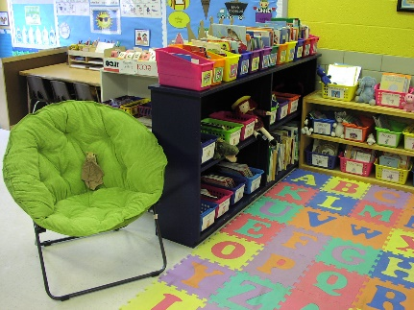
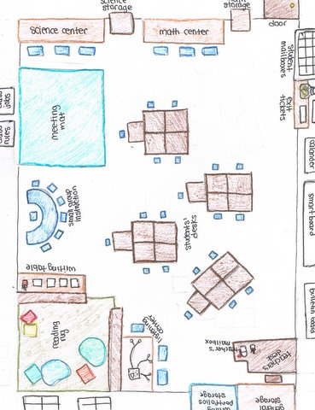
This appendix has examples of a classroom letter, setup and more that I would like to incorporate into my classroom.
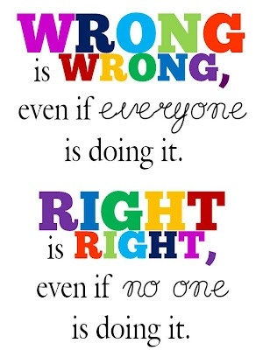
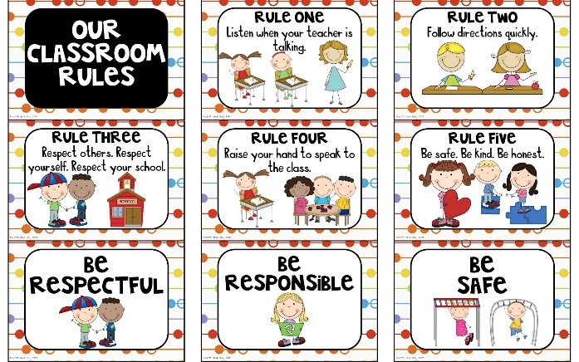
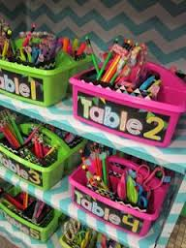
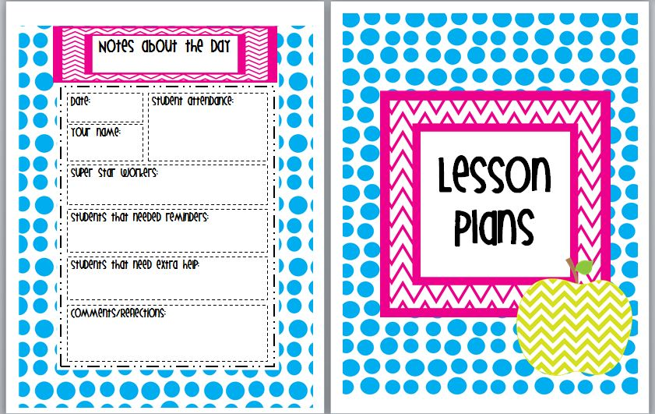
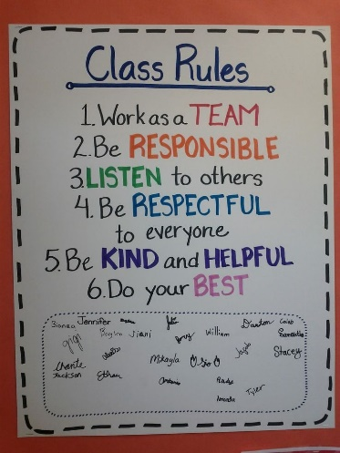
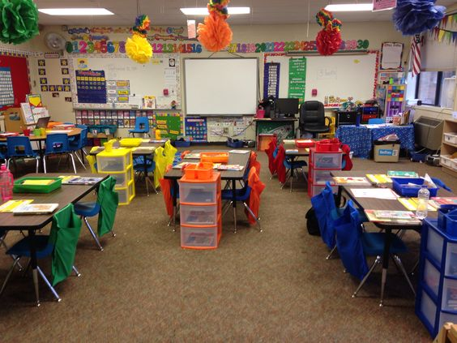
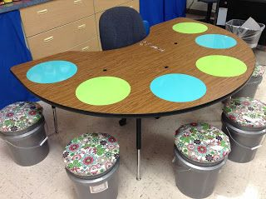
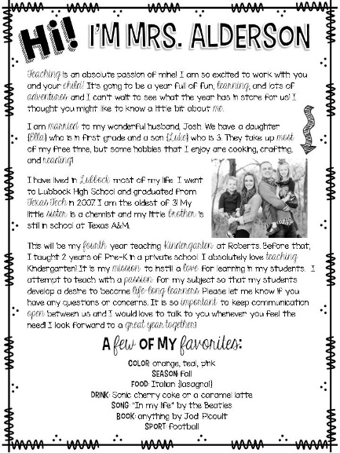
I will have a binder prepared for my substitute teacher with nearly everything they will need in my absence.
This is an example of an introductory letter to my students and parents that gives a little bit of information about me and what I like.
This would be my small group table. I like the dry erase stickers, so I can use them instead of having the kids get white boards. Above and beside are examples of how I would like to set up my classroom. I would color code or give each table a name to and they would be a “team” of sorts.
This would be my reading corner that allows for students to go during free time or to relax if they are stressed.

